- Log in to http://www.SKSLL.com (or register if you haven’t already).
- Click on “Volunteer” and then click “Find Volunteer Roles”.
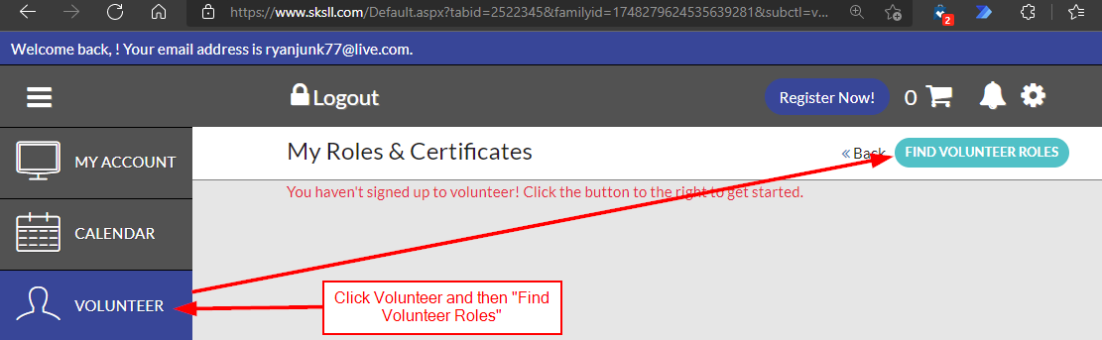
- If this is the first time using our system, you will be asked to enter your basic user information and hit next. If your screen doesn’t match below, skip to step 5.
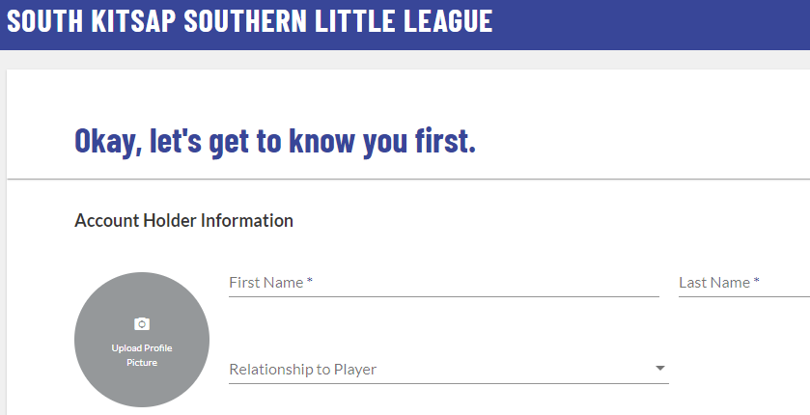
- Select “View Divisions” for the current season/program.
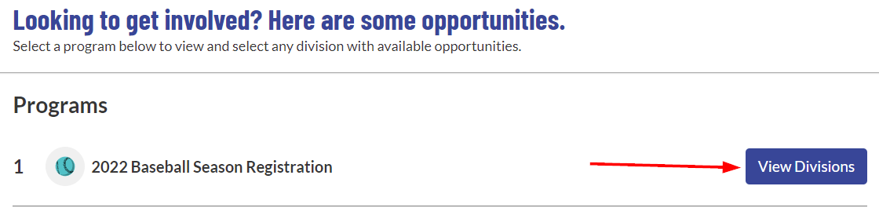
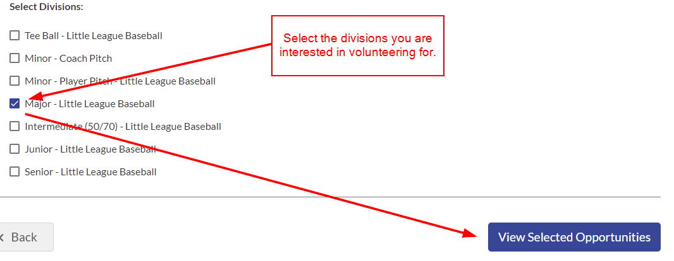
- Select the category you would like to volunteer for, select the person to sign up, and then click “Continue”. The middle image below may look slightly different for you.
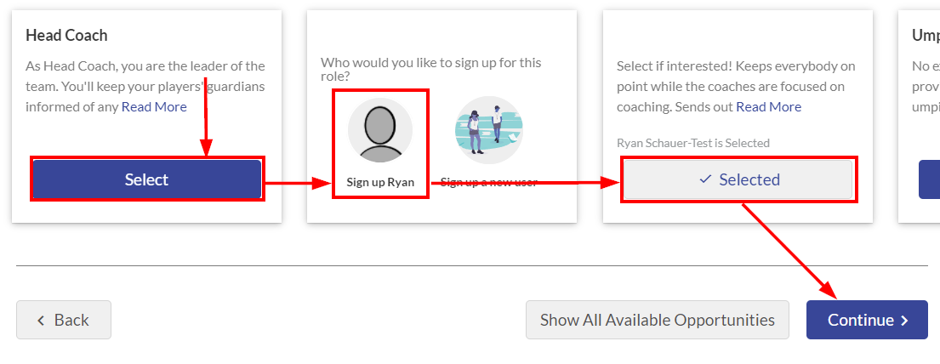
- Complete the required volunteer information and submit the form.
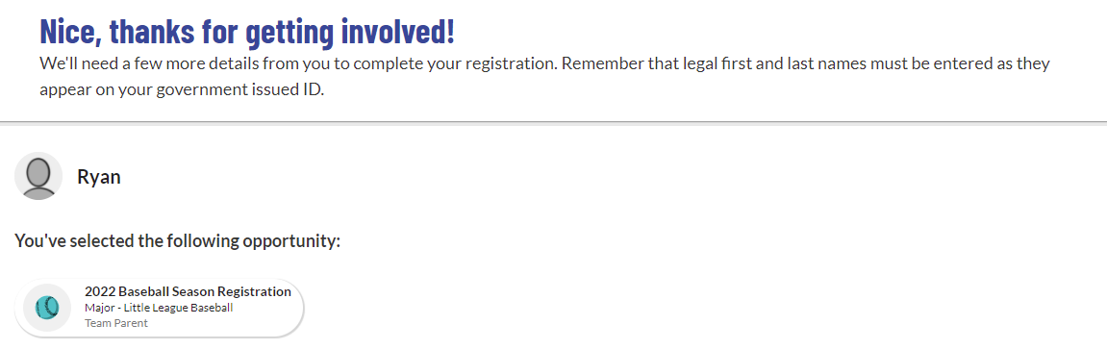
- Once we process your request, you will receive an email from Little League asking you to complete a “Volunteer Application”. This is the background check that is required for all volunteers. Please, enter your information exactly how it is on your drivers license or else we’ll need you to resubmit it.

